Progressive Report

1. Background

This project focuses on exploring how the consensus and earnings (beat/miss) reflect on stock price changes, therefore suggestions can be made to support stock trading activities. I used to analyze the relationship between beat/miss with alpha, now I mainly focus on stock price, retrace period when a retrace range is given. I generate some visualization results.

1. Data

The data I used for analysis is each **10 equities** from USA, **semiconductor** and **IT**. I used 10 years beat/miss and stock price data. However, the historical range can be specified as we want.

1. Assumptions

There are some assumptions for the analysis:

1. Definition of “up/down”

Up: ① average of the first four trading days ***above*** zero

② In the first four trading days, three of them have a return ***greater*** than zero

Down: ① average of the first four trading days ***below*** zero

② In the first four trading days, three of them have a return ***lower*** than zero

1. Retrace threshold: In my assumption, when day ***t*** retraces from the maximum/minimum stock price by a certain retrace threshold, then t is the retreat period.
2. Results

[Beat threshold = 5%, Miss threshold = 1%, Date Range: 2019-2025, Retrace threshold =5%]

1. **Distribution of Retrace Period for Beat Up**

For beat up in semiconductor, the retrace period locates most between day5-10, while for IT it’s between day5- 19. The number of data is not sufficient so the counts for different Retrace period is 1 or 2.

1. **Distribution of Retrace Period for Beat Down**

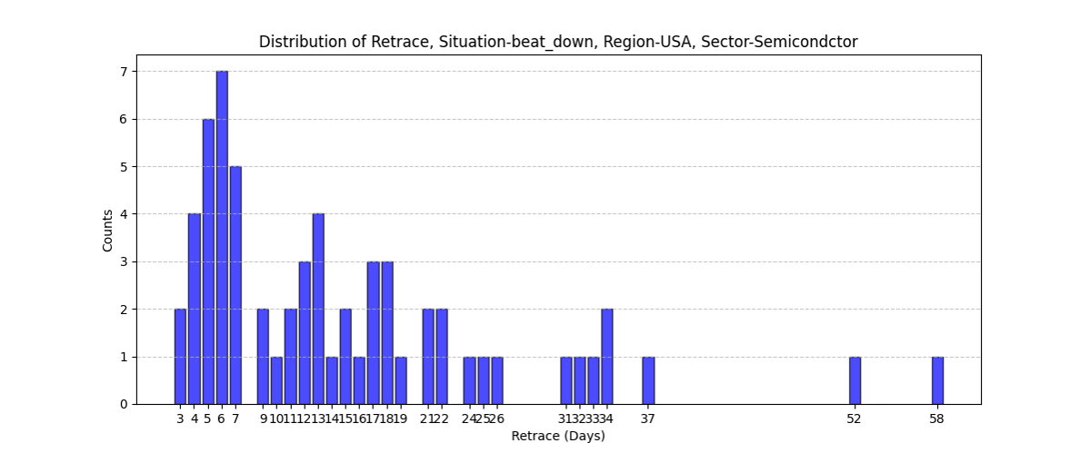

For beat up in semiconductor, the retrace period locates most between day4-7, while for IT it’s between day3- 6. The retrace period for beat down is usually shorter than beat up.

1. **Almost every beat up/down has a retrace**

According to the analysis data, there are 130 beat up/down and only one of them has no retrace of 5% in 60 days.

1. **The number of Miss is much less than Beat**

There are 130 beat data and only 10 miss data. This happens in both semiconductors and IT. Therefore, the analysis of miss is hard to proceed.

1. **5% retrace VS 10% retrace**

**(5% retrace)**

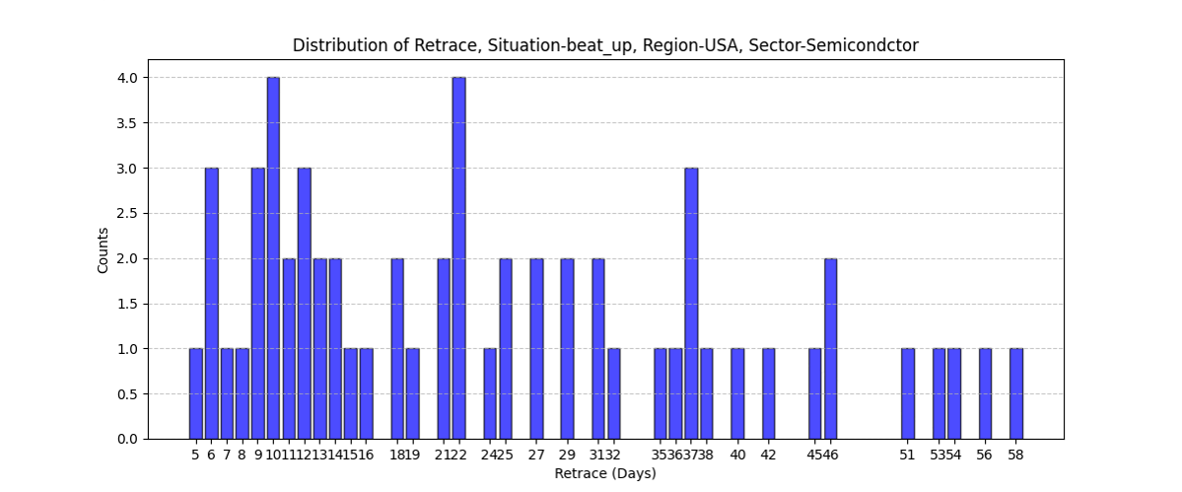

**(10% retrace)**

A 10% retrace is essentially a whole 4 days shift backward compared to a 5% retrace based on the figure.

1. **Relationship between beat size and retrace period**

There’s no significant relationship between beat size and retrace period according to statistical tests. The scatter figure is plotted below. I think categorizing further by the trend or stock sentiment before earnings might be useful for discovery patterns.

1. **Next Step**

I think a discussion is necessary for the next step:

1. How we define an up or down after earnings. (refer to chapter 3)
2. How do we define retrace. Retrace from the initial or maximum. (refer to chapter 3)

What I can do next:

1. Increase more equities to analyze and seek patterns from big data. (100+ equities for one sector)
2. Involve more stock indicators for analysis.
3. Using some Machine learning methods for ①retrace period predictions ②predict whether there’s a up or a down after beat/miss③other topics if necessary